**Assignment Date : 29-09-2022**

**Name : SRAVANI T**

**Reg No : 111519106153**

**Maximum Marks : 2Marks**

**Question**

**1.Write A Python Code For Traffic Lights For Raspberry Pi.**

**Code:**

voidsetup() {

  // put your setup code here, to run once:

  Serial1.begin(9600);

  pinMode(21, OUTPUT);

  pinMode(20, OUTPUT);

  pinMode(19, OUTPUT);

}

voidloop() {

  // put your main code here, to run repeatedly:

  digitalWrite(21, HIGH);

  delay(3000); // this speeds up the simulation

  digitalWrite(21, LOW);

  digitalWrite(20, HIGH);

  delay(3000);

  digitalWrite(20, LOW);

  digitalWrite(19, HIGH);

  delay(3000);

  digitalWrite(19, LOW);

}

OUTPUT:

1. RED LIGHT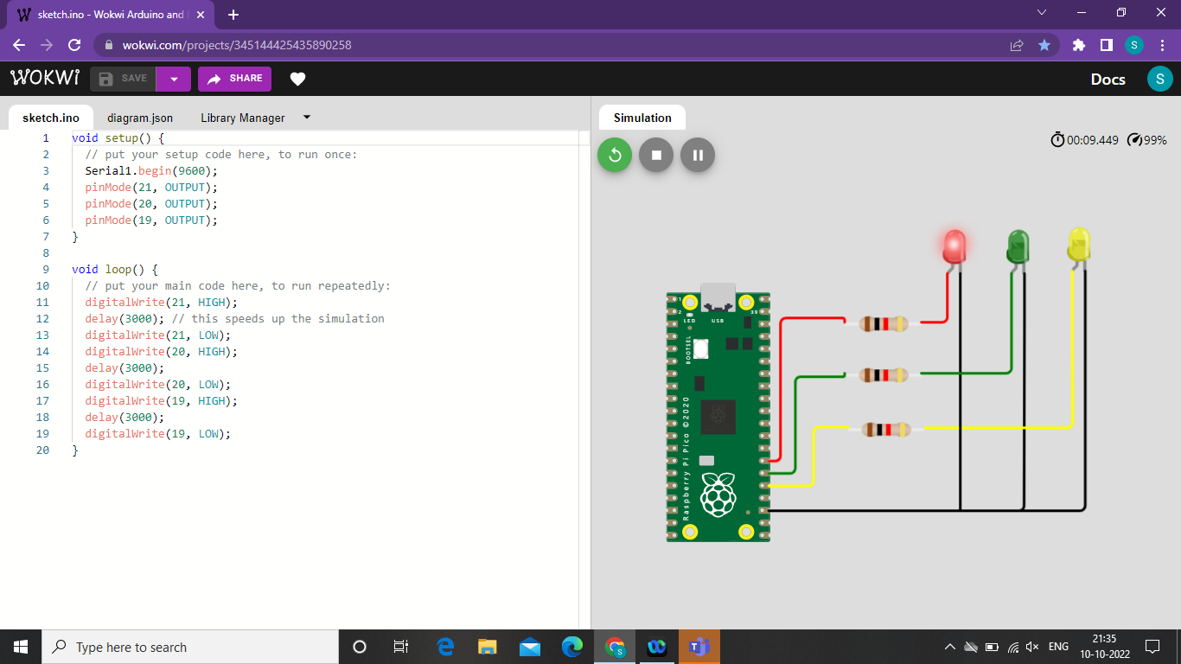
2. GREEN LIGHT

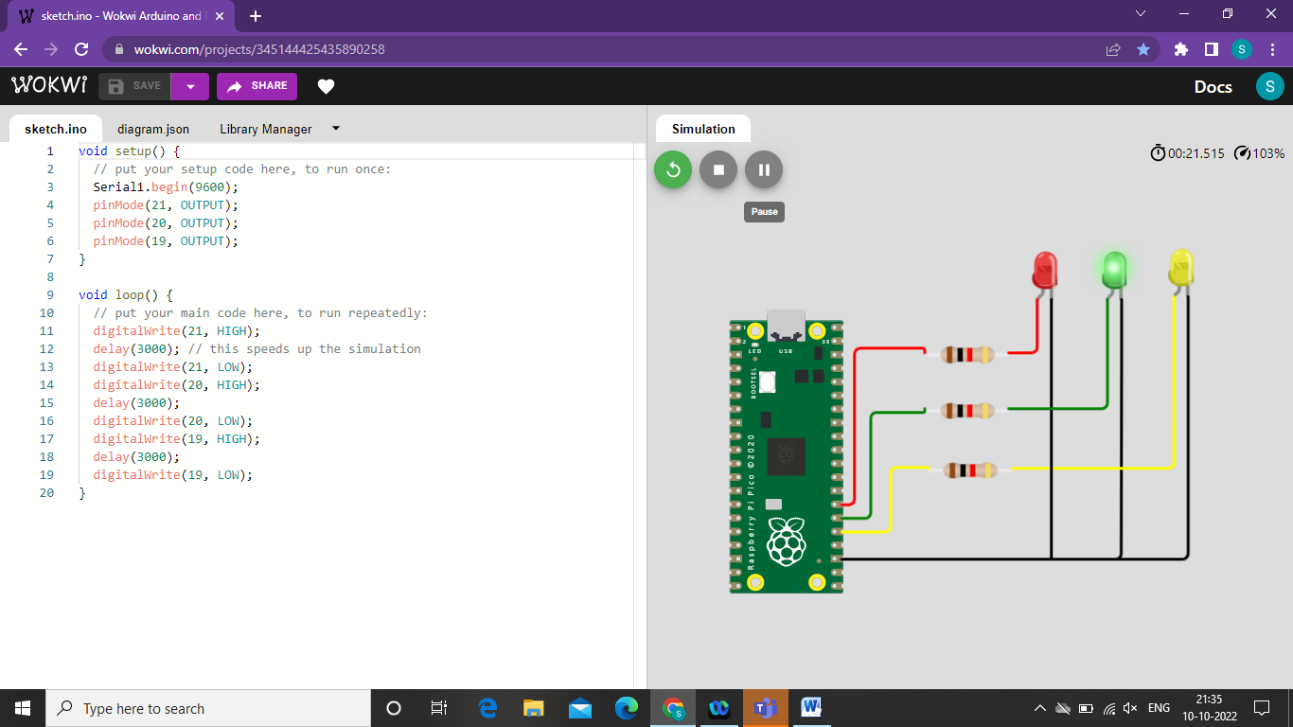

3.YELLOW LIGHT

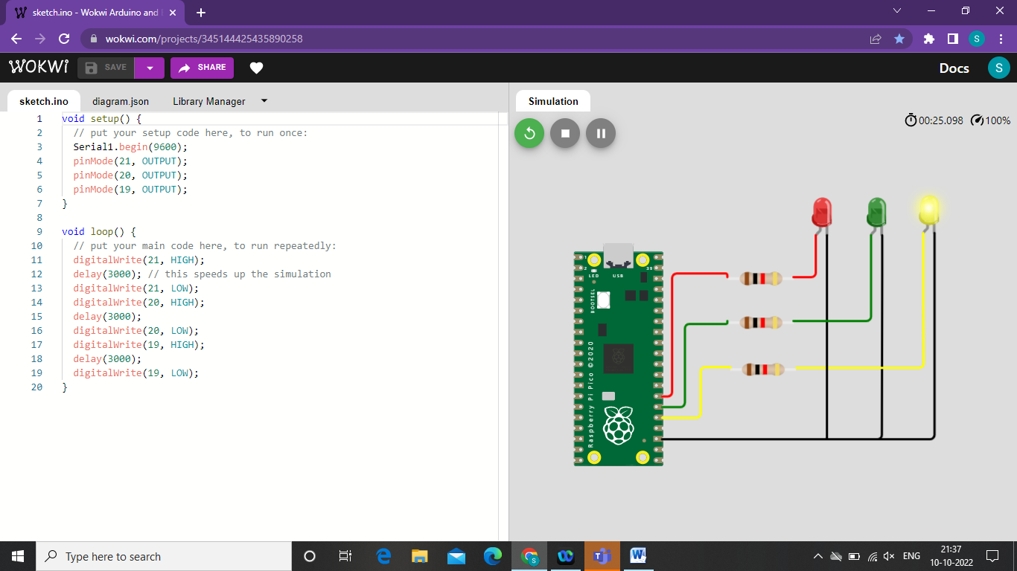

**2.Write A Python Code For Blinking Led For Raspberry Pi.**

Code:

void setup() {

// put your setup code here, to run once:

Serial1.begin(9600);

pinMode(22, OUTPUT);

}

void loop() {

// put your main code here, to run repeatedly:

digitalWrite(22, HIGH);

Serial.println("LED ON");

delay(2000); // this speeds up the simulation

digitalWrite(22, LOW);

Serial.println("LED OFF");

delay(2000);

}

